**8**. **ReactJS – HOL**

**1. What is React State?**

* State is a built-in object in React used to store data inside a component.
* This data can change over time, like user input, button clicks, etc.
* When state changes, React automatically re-renders the component to reflect the update.

**2. How to Use React State (Hands-on Steps)**

**Example**

A counter that increases on button click.

**Step 1: Import useState**

import React, { useState } from 'react';

**Step 2: Create a Functional Component with State**

function Counter() {

const [count, setCount] = useState(0); // Initial state is 0

return (

<div>

<h2>Count: {count}</h2>

<button onClick={() => setCount(count + 1)}>Increment</button>

</div>

);

**React Application : counterapp**

Create a React App “counterapp” which will have a component named “CountPeople” which will have 2 methods.

UpdateEntry() 🡪 which will display the number of people who entered the mall.

UpdateExit() 🡪 which will display the number of people who exited the mall.

Use Constructor and state to Store the entrycount and exitcount.

The component has 2 buttons

1. Login 🡪 when clicked, the entrycount should get incremented by 1
2. Exit 🡪 when clicked, the exitcount should get incremented by 1

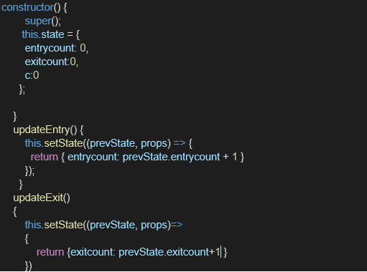

**Final Ouput:**

